ACKNOWLEDGEMENT

Before getting into the thick of the things, we would like to express our deep gratitude to the people who helped us during the course of this project. We are grateful to our project guide for her guidance throughout this project research and work
We also wish to thank all the faculty members of Information Technology and our respectable Head of Department for their constant help and efficient teaching procedures,

Names of students:

)

ABSTRACT

The Insurance management system is a complete solution for organizations, which need to manage insurance for their vehicles, equipment, buildings, and other resources. Organizes and tracks insurance vendors and the policies provided under different coverage.
We are offering a robust web based insurance solution, which has the flexibility of customizations to match the specific needs of clients for achieving their business goal of good service and revenue generation.
Insurance policy administration system consists of a mathematical notation that captures the relationship between policies and objects and the entities that manage policies for those objects.
Hence there is need for an automated system, which can efficiently manage the company, records, provides instant access and one that improves the productivity. As a result of this automated system, the activities of the company are performed with in the stipulated time and the reliable and efficient service is ensured to its users.
The insurance company needs to keep track of details of its target companies, agents, policyholders, their premium payments and the various products that are available with it. Hence it is under tremendous pressure maintaining their day-to-day activities, which is currently being done manually.
Entire records have to be updated timely, even a slight mistake could complicate things. It
is very difficult to handle bulk data since human memory is weaker than electronic counter part. It is time consuming to summarize these details to produce the reports.

INDEX

- Acknowledgement--------------------------------------------1
- Abstract---------------------------------------------------------2
- Introduction----------------------------------------------------4
- Overview--------------------------------------------------------5
- ER Diagram-----------------------------------------------------7
- Converting ER Diagram into Tables-----------------------8
- Table Structures-----------------------------------------------9
- Normalisation--------------------------------------------------13
- Code--------------------------------------------------------------14
- Snapshots-------------------------------------------------------43
- Conclusion------------------------------------------------------49
- Scope of Enhancement---------------------------------------49

INTRODUCTION

Visual Basic is an interesting topic, which has different types. It has all the methods have their won features with each having merits and demerits which help in data processing. The topic includes their architecture representing the elements involved in it and their action is also specified.

Visual Basic 6.0 allows creating object-oriented applications. Visual Basic 6.0 profoundly concentrates on the Internet development features, Active X technology, enhanced controls, enhanced features of existing control, client/server, new language features development, data access, a few design enhancement etc.,

Relational databases are logical collection of inter-related data in tabular form relational databases have always been core to any management system. Its relevance is profound and hence the need to incorporate new functionalities, utilities becomes important. These are currently the predominant choice in storing financial records manufacturing and logistical information, personnel data and much more.
Relational databases are used in huge management systems like Post Office, Banking, Railway, Defence Logistics. Databases pertaining to Educational Institutions and other large collection of related data.
Relational databases have largely replaced hierarchical databases and network databases because they are easy to understand and use even though they are much less efficient. They have been however challenged by Object Databases and XML databases.
The three leading commercial relational database vendors are Oracle, Microsoft, and IBM.The three leading open Source implementations are MySQL,PostgreSQL, and SQLite.
The software components used in our project are as under:
- Microsoft Visual Basic 6.0
- Oracle 9i database
- VMware Workstation
SYSTEM REQUIREMENTS:-
- Windows Platform (XP preferred).
- 512 MB DDR2 RAM.
- At least 5 GB HDD space FREE.
- Processor speed 1.7 Ghz or higher.

OVERVIEW OF THE PROJECT

SYSTEM DESCRIPTION:
The proposed system is for making easier to manage policy holder details, agent details, policy details, claimant details and payment details. So this will be developed for managing the insurance management system. The overall system is control through the main menu.
The main menu contains 6 parts.
- Policy Schemes.
- Agent Login.
- Customer Login.
- Administrator Login.
- About us.
- Contact us.

POLICY SCHEMES:-
Various policy schemes are:-
- LIFE INSURANCE:-
- Whole life policy
- Term life policy
- Endownment policy
- Pension plans
- GENERAL INSURANCE:-
- Home insurance
- Auto insurance
- Fire insurance

AGENT LOGIN
The agent login form links to-
- Basic agent information like contact details and address which will be shown in customer insurance information window.
- All the information related to insurances which he has made to his clients.
- Commission received by him for each insurance made by him respectively.
- Option to create a new policy to any existing/new client.
- Option to edit the contact information of its client.
- Option to delete a policy of any client in case of policy lapse.

CUSTOMER LOGIN:-
The form contains the agent information like-
- Personal information required by insurance agency.
- Next premium due of respective insurances by the client along with maturity date,agent info etc.

ADMINISTRATOR LOGIN:-
Administrator has rights to-
- Create new agent
- Edit agent’s information and its commission percentage.
- Delete an agent’s database and all its policies respectively.

ABOUT US:-
It contains information about the organization’s history and its achievements.

CONTACT US:-
It contains the contact details of the organization’s various branches located in different parts of a country.

REPORTS:
- Sales report
- Claimant information report
- Agent information report
- Client information report

ER DIAGRAM

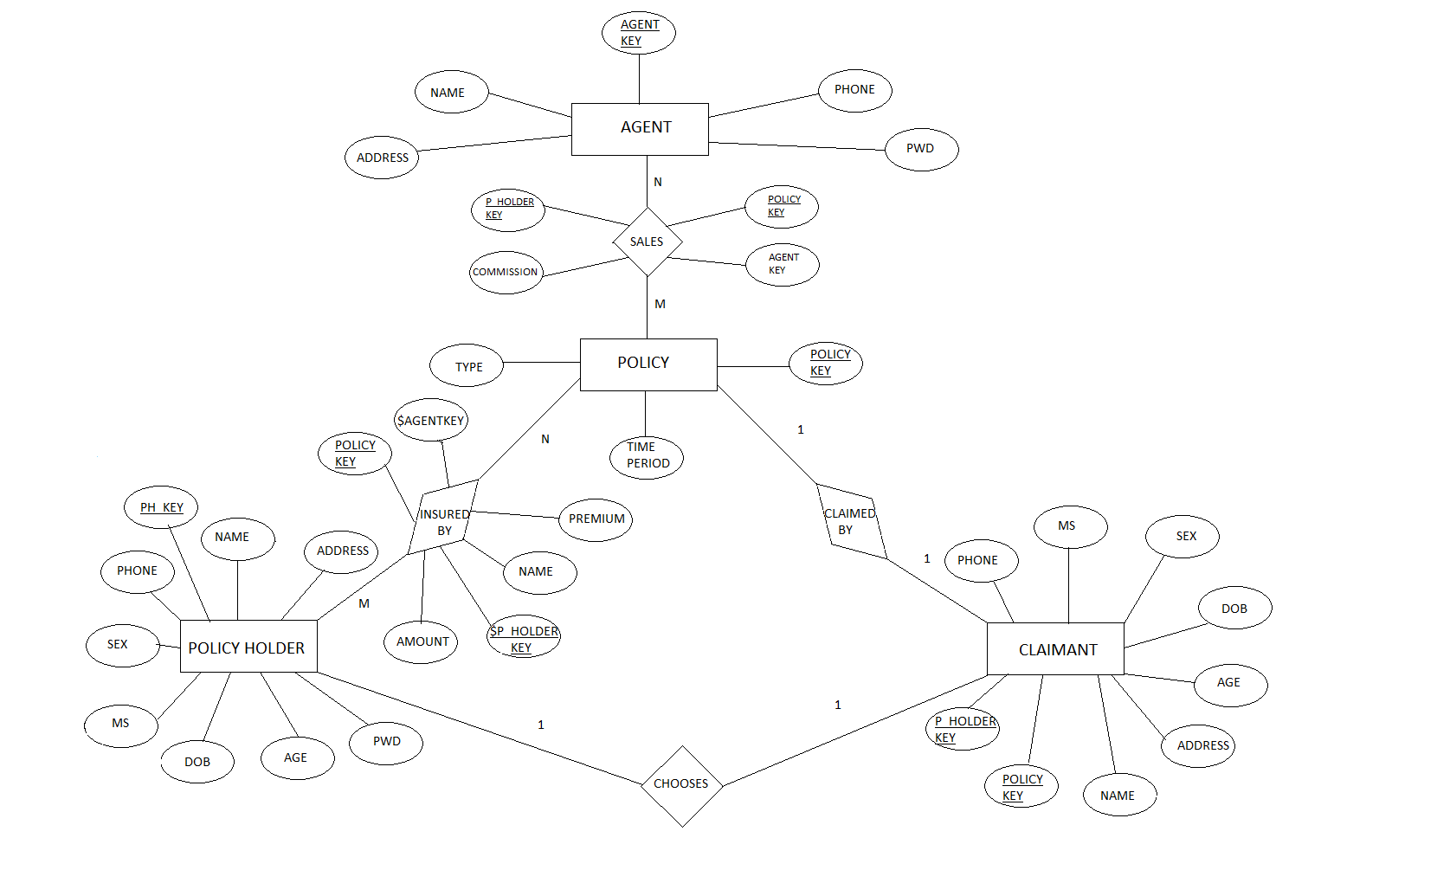

CONVERTING ER DIAGRAM INTO TABLES
- Converting strong entity types
    - Each entity type becomes a table
    - Each single valued attribute becomes a column
    - Derived attributes are ignored
    - Composite attributes are represented by components
    - Multi-valued attributes are represented by a separate table
    - Key attributes of the entity type is the Primary Key
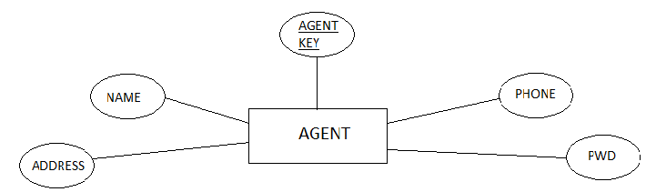

- Converting relationships
    - Relationships are based on cardinalities and degree of the relation
- m:n
INSURED BY
POLICY HOLDER
POLICY

m n

- Binary 1:1

CHOOSES
POLICY HOLDER
CLAIMANT

1 1

- Relations converted
- Policy holder and policy have m:n cardinality which results in conversion of the relation ‘insured by’ into a table named as ‘insurance’. The insurance table has ph_key and pol_key from policy holder table and policy table respectively ,as its composite primary key.
- Also policy and agent table have m:n cardinality resulting in conversion of relation ‘sales’, into a table named as ‘sales’. The table sales has ph_key and pol_key from policy holder table and policy table respectively ,as its composite primary key and agent key from agent table as a foreign key.

TABLE STRUCTURES
The structure of all tables included in the project is as under:-
1. PH
Name Null? Type
----------------------------------------- -------- ----------------------------
* PH_KEY NOT NULL NUMBER(5)
NAME CHAR(15)
ADDRESS CHAR(15)
PHONE NUMBER(10)
PWD VARCHAR2(10)
DOB DATE
AGE NUMBER(2)
MS VARCHAR2(10)
SEX VARCHAR2(6)
SAL NUMBER(10)

2. AGENT
Name Null? Type
----------------------------------------- -------- ----------------------------
NAME CHAR(20)
ADDRESS CHAR(32)
PHONE NUMBER(10)
* ID NOT NULL NUMBER(5)
PWD VARCHAR2(10)

3. INSURANCE
Name Null? Type
----------------------------------------- -------- -----------------
PREMIUM NUMBER (10)
AMOUNT NUMBER (10)
POLICY_DURATION NUMBER (4)
$ P_HOLDER NOT NULL NUMBER (5)
$ POLICY_KEY NOT NULL NUMBER (5)
IODATE DATE

4. SALES
Name Null? Type
----------------------------------------- -------- -----------------
$ AGENT_KEY NUMBER (5)
COMMISSION NUMBER (10)
$ P_HOLDER NOT NULL NUMBER (5)
$ POLICY_KEY NOT NULL NUMBER (3)

5. POLICY
Name Null? Type
----------------------------------------- -------- -----------------
* POL_KEY NOT NULL NUMBER(3)
TYPE CHAR(32)
TIME_PER NUMBER(4)

6.CLAIMANT
Name Null? Type
----------------------------------------- -------- -----------------
NAME NOT NULL VARCHAR2(50)
ADDRESS NOT NULL VARCHAR2(50)
$ P_HOLDER NOT NULL NUMBER(5)
$ POLICY_KEY NOT NULL NUMBER(3)
SEX CHAR(6)
DOB DATE
MS CHAR(10)
AGE NUMBER(3)
PHONE NUMBER(10)

VIEW STRUCTURES
1.POL
Name Null? Type
----------------------------------------- -------- -----------------
P_HOLDER NOT NULL NUMBER(5)
TYPE CHAR(32)
POL_KEY NOT NULL NUMBER(3)

2.INS
Name Null? Type
----------------------------------------- -------- -----------------
NAME NOT NULL VARCHAR2(50)
PREMIUM NUMBER(10)
AMOUNT NUMBER(10)
POLICY_DURATION NUMBER(4)
P_HOLDER NOT NULL NUMBER(5)
IODATE DATE
POLICY_KEY NOT NULL NUMBER(3)

3.CLIENT
Name Null? Type
----------------------------------------- -------- -----------------
AGENT_KEY NUMBER(5)
PH_KEY NOT NULL NUMBER(5)
NAME CHAR(15)
ADDRESS CHAR(15)
PHONE NUMBER(10)
PREMIUM NUMBER(10)
AMOUNT NUMBER(10)
POLICY_DURATION NUMBER(4)
TYPE CHAR(32)
IODATE DATE

NORMALISATION
Own table normalization

Normalisation is a method for organizing data elements in a database into tables.
It keeps track to keep the database less vulnerable to some types of logical inconsistencies and anomalies.Tablescan be normalized to varying degrees like first,second,BCNF.Greater the degree of normalization more is the protected from inconsistencies and anomalies.
The tables may be normalized under the following guideline:
- 1NF
DEFINITION:
A relation schema is in 1NF if all of its attributes are:
- Single valued
- Restricted to assuming atomic values
- Functionally dependent on the primary key
Domain is atomic if its elements are considered to be indivisible units .
Examples of non-atomic domains
Set of names, composite attributes
- Identification numbers like ph_key that can be broken up into parts
- A relational schema R is in first normal form if the domains of all attributes of R are atomic.
- All domains in our database are atomic since they are indivisible.
- No Duplication of data ,Insert Anomaly ,Delete Anomaly ,Update Anomaly found, therefore our database clears the first normal form test.

- 2NF

DEFINITION:
A relational table is said to be in second normal form 2NF if it is in 1NF and every non-key attribute is fully functionally dependent upon primary key.
The criteria for second normal form(2NF) are:
- The table must be in !NF.
- Every non-key attributes of the table must be dependent upon the entire primary key.
- Tables agent ,policy holder ,claimant ,insurance ,sales are also in 2NF.
- our database satisfies all the conditions of 2NF since The tables are in 1NF and Every non-key attributes of the table must be dependent upon the entire primary key.

- 3NF
- A relation is in 3NF if and only if,it is in 2NF and there are no transitive functional dependencies.
- Transitive functional dependencies arise.
- When one non-key attribute is functionally dependent on another non-key attribute.
- Functional Dependency: non-key attribute>non-key attribute.
- When there is redundancy in the database.
- The tables insurance ,claimant ,policy holder and sales have been converted into 3NF.
By definition transitive functional dependency can only occur if there is more than one non-key field,so we can say that a relation in 2NF with zero or one non-key field must automatically be in 3NF.

CODES
ADDPOL FORM
Private Sub Command1_Click()
r2.Open "select * from ph", cn, 2, 3
r3.Open "select * from sales", cn, 2, 3
rs.Open "select * from insurance", cn, 2, 3
r4.Open "select * from claimant", cn, 2, 3
strsql = "insert into ph values(" & Text4(0).Text & ",'" & Text4(1).Text & "','" & Text4(2).Text & "'," & Text4(3).Text & ",'" & Text5.Text & "'," & Text6.Text & ",'" & Text4(5).Text & "'," & Text4(6).Text & ",'" & Text4(7).Text & "','" & Text4(4).Text & "')"
strsql1 = "insert into sales values(" & agpg.Label5.Caption & "," & 0.05 * Text2.Text & "," & Text4(0).Text & "," & Label16.Caption & ")"
strsql2 = "insert into insurance values(" & Text2.Text / Text3.Text & "," & Text2.Text & "," & Text3.Text & "," & Text4(0).Text & "," & Label16.Caption & ",' " & Text1.Text & "')"
strsql3 = "insert into claimant values('" & Text7.Text & "','" & Text9.Text & "'," & Text4(0).Text & "," & Label16.Caption & ",'" & Text10.Text & "','" & Text12.Text & "','" & Text11.Text & "'," & Text13.Text & "," & Text8.Text & ")"
cn.Execute strsql
cn.Execute strsql1
cn.Execute strsql2
cn.Execute strsql3
MsgBox "added"
End Sub

Private Sub Command3_Click()
agpg.Show
agpg.Label13.Visible = True
Unload Me
End Sub

Private Sub Form_Load()
On Error Resume Next
cmd1 = "Provider=MSDAORA.1;User ID=scott;password=tiger;Persist Security Info=False"

Set cn = New ADODB.Connection
Set rs = New ADODB.Recordset
Set r4 = New ADODB.Recordset
Set r1 = New ADODB.Recordset
Set r2 = New ADODB.Recordset
Set r3 = New ADODB.Recordset
With cn
.ConnectionString = cmd1
.CursorLocation = adUseClient
.Open
End With

r1.Open "select * from policy", cn, 2, 3

Do While Not r1.EOF
Combo1.AddItem (r1.Fields(1))
r1.MoveNext

Loop
End Sub

Private Sub Label16_Click()
r1.MoveFirst
Do While Not r1.EOF
If Combo1.Text = r1.Fields(1) Then
Label16.Caption = r1.Fields(0)
Exit Do
End If
r1.MoveNext
Loop
End Sub

ADMN FORM
Private Sub Command1_Click()
Dim flag As Integer
r1.MoveFirst
r2.MoveFirst
r3.MoveFirst
rs.MoveFirst
'Do While Not r1.EOF
'If r1.Fields(3) = Combo2.Text Then
If MsgBox("Are you sure you to delete this agent?", vbYesNo) = vbYes Then
Do While Not r2.EOF
If r2.Fields(0) = Combo2.Text Then
r3.MoveFirst
Do While Not r3.EOF
If r2.Fields(2) = r3.Fields(3) And r2.Fields(3) = r3.Fields(4) Then
r3.Delete
End If
r3.MoveNext
Loop
Do While Not rs.EOF
If r2.Fields(2) = rs.Fields(2) And r2.Fields(3) = rs.Fields(3) Then
rs.Delete
End If
rs.MoveNext
Loop

End If
r2.MoveNext
Loop
End If

r2.MoveFirst
Do While Not r2.EOF
If r2.Fields(0) = Combo2.Text Then
r2.Delete
End If
r2.MoveNext
Loop
r1.MoveFirst
Do While Not r1.EOF
If r1.Fields(3) = Combo2.Text Then
r1.Delete
Exit Do
End If
r1.MoveNext
Loop

MsgBox "deleted"

End Sub

Private Sub Command2_Click()
Frame2(1).Visible = True
Frame2(0).Visible = False
End Sub

Private Sub Command3_Click()
aginfo.Show
End Sub

Private Sub Command4_Click(Index As Integer)
strsql = "insert into agent values('" & Text1(0).Text & "','" & Text2(0).Text & "'," & Text3(0).Text & "," & Text4(0).Text & ",'" & Text5(0).Text & "')"
cn.Execute strsql
MsgBox "Agent successfully added"
End Sub

Private Sub Command5_Click()
Frame2(0).Visible = True
Frame2(1).Visible = False
End Sub

Private Sub Command7_Click()
Dim strsql1 As String
strsql1 = "update agent set name= '" & Text1(1) & "',address='" & Text2(1) & "',phone=" & Text3(1) & "where id=" & Combo1.Text
cn.Execute strsql1
MsgBox "Entry successfully editted"
End Sub

Private Sub Command8_Click()
r1.MoveFirst
Do While Not r1.EOF
If r1.Fields(3) = Combo1.Text Then
Text3(1) = r1.Fields(2)
Text2(1) = r1.Fields(1)
Text1(1) = r1.Fields(0)
Text4(1) = r1.Fields(4)
Text5(1) = r1.Fields(3)
Exit Do
End If
r1.MoveNext
Loop
End Sub

Private Sub Command9_Click()
main1.Show
Unload Me
End Sub

Private Sub Form_Load()
Frame2(0).Visible = False
Frame2(1).Visible = False
On Error Resume Next
cmd1 = "Provider=MSDAORA.1;User ID=scott;password=tiger;Persist Security Info=False"

Set cn = New ADODB.Connection
Set rs = New ADODB.Recordset
Set r1 = New ADODB.Recordset
Set r2 = New ADODB.Recordset
Set r3 = New ADODB.Recordset
Set rk = New ADODB.Recordset
With cn
.ConnectionString = cmd1
.CursorLocation = adUseClient
.Open
End With
r1.Open "select * from agent", cn, 2, 3
r2.Open "select * from sales", cn, 2, 3
r3.Open "select * from insurance", cn, 2, 3
rs.Open "select * from claimant", cn, 2, 3
rk.Open "select * from ph", cn, 2, 3
r1.MoveFirst
Do While Not r1.EOF
Combo1.AddItem (r1.Fields(3))
Combo2.AddItem (r1.Fields(3))
r1.MoveNext
Loop

End Sub

Agninfo form
Private Sub Command1_Click()
strsql = "select name,premium,type,policy_duration,commission,amount from adm where agent_key=" & Combo1.Text
r2.Open strsql, cn, 2, 3
Set dg.DataSource = r2
dg.Refresh
End Sub

Private Sub Command2_Click()
admn.Show
Unload Me
End Sub

Private Sub Form_Load()
On Error Resume Next
cmd1 = "Provider=MSDAORA.1;User ID=scott;password=tiger;Persist Security Info=False"
Set cn = New ADODB.Connection
Set rs = New ADODB.Recordset
Set r2 = New ADODB.Recordset
Set rk = New ADODB.Recordset
With cn
.ConnectionString = cmd1
.CursorLocation = adUseClient
.Open
End With
rs.Open "select * from agent", cn, 2, 3

Do While Not rs.EOF
Combo1.AddItem (rs.Fields(3))
rs.MoveNext
Loop

End Sub

Agpg Form
Private Sub Command1_Click()
addpol.Show
End Sub

Private Sub Command2_Click()
Dim flag As Integer
r2.MoveFirst

Do While Not r2.EOF
If r2.Fields(8) = Combo1.Text And r2.Fields(1) = Combo2.Text Then
If MsgBox("Are you sure you to delete this customer?", vbYesNo) = vbYes Then
strsql1 = "delete from insurance where p_holder=" & Combo2.Text & " and policy_key=" & Label12.Caption
strsql2 = "delete from sales where p_holder=" & Combo2.Text & " and policy_key=" & Label12.Caption
strsql3 = "delete from claimant where p_holder=" & Combo2.Text & " and policy_key=" & Label12.Caption

Do While Not r4.EOF
If r4.Fields(1) = Combo2.Text Then
flag = flag + 1
End If
r4.MoveNext
Loop
MsgBox strsql1
cn.Execute strsql1
MsgBox strsql2
cn.Execute strsql2
MsgBox strsql3
cn.Execute strsql3
If flag = 1 Then
strsql4 = "delete from ph where ph_key=" & Combo2.Text
MsgBox strsql4
cn.Execute strsql4
End If
MsgBox "deleted"
End If
Exit Do
End If
r2.MoveNext
Loop
End Sub

Private Sub Command3_Click()
pass.Show
End Sub

Private Sub Command4_Click()
edtpol.Show
End Sub

Private Sub Command5_Click()

End Sub

Private Sub Command6_Click()
main1.Show
Unload Me
End Sub

Private Sub Form_Load()

On Error Resume Next
cmd1 = "Provider=MSDAORA.1;User ID=scott;password=tiger;Persist Security Info=False"
Set cn = New ADODB.Connection
Set rs = New ADODB.Recordset
Set rk = New ADODB.Recordset
Set r1 = New ADODB.Recordset
Set r2 = New ADODB.Recordset
Set r3 = New ADODB.Recordset
Set r4 = New ADODB.Recordset
Set r5 = New ADODB.Recordset
With cn
.ConnectionString = cmd1
.CursorLocation = adUseClient
.Open
End With

rs.Open "SELECT * FROM agent", cn, 2, 3
rk.Open "SELECT * FROM client", cn, 2, 3
r1.Open "SELECT * FROM policy", cn, 2, 3

Do While Not rs.EOF
If rs.Fields(3) = j Then
Label5.Caption = rs.Fields(3)
Label6.Caption = rs.Fields(0)
Label7.Caption = rs.Fields(1)
Label8.Caption = rs.Fields(2)
Exit Do
End If
rs.MoveNext
Loop

strsql = "select * from client where agent_key= " & j
r2.Open strsql, cn, 2, 3
Set dg1.DataSource = r2
dg1.Refresh

Do While Not r2.EOF
Combo1.AddItem r2!Type
Combo2.AddItem r2!ph_key
r2.MoveNext
Loop

rs.MoveFirst

Label13.Visible = False

r4.Open "select * from client", cn, 2, 3
End Sub

Private Sub MSHFlexGrid1_Click()

End Sub

Private Sub Label12_Click()
r3.Open "SELECT * FROM policy", cn, 2, 3
r3.MoveFirst
Do While Not r3.EOF
If r3.Fields(1) = Combo1.Text Then
Label12.Caption = r3.Fields(0)
Exit Do
End If
r3.MoveNext
Loop
End Sub

Cinfo form
Private Sub Command1_Click()
rk.MoveFirst
r2.MoveFirst
Do While Not rk.EOF
If Combo1.Text = rk.Fields(1) Then
Do While Not r2.EOF
If rk.Fields(0) = r2.Fields(4) And rk.Fields(2) = r2.Fields(6) Then
For i = 0 To Label18.Count - 1
If i <> 4 Then
Label18(i).Caption = r2.Fields(i)
End If
Next
Exit Do
End If
r2.MoveNext
Loop
End If
rk.MoveNext
Loop

End Sub

Private Sub Command2_Click()
rk.MoveFirst
r3.MoveFirst
ag.MoveFirst
Do While Not rk.EOF
If Combo2.Text = rk.Fields(1) Then
Do While Not r3.EOF
If rk.Fields(0) = r3.Fields(2) And rk.Fields(2) = r3.Fields(3) Then
Do While Not ag.EOF
If r3.Fields(0) = ag.Fields(3) Then
For i = 0 To Label23.Count - 1
Label23(i).Caption = ag.Fields(i)
Next

Exit Do
End If
ag.MoveNext
Loop
Exit Do
End If
r3.MoveNext
Loop
Exit Do
End If
rk.MoveNext
Loop

End Sub

Private Sub Command3_Click()
rk.MoveFirst
r4.MoveFirst
Do While Not rk.EOF
If Combo3.Text = rk.Fields(1) Then
Do While Not r4.EOF
If rk.Fields(0) = r4.Fields(2) And rk.Fields(2) = r4.Fields(3) Then
For i = 0 To Label33.Count - 1
If i <> 3 Then
Label33(i).Caption = r4.Fields(i)
End If
Next
Exit Do
End If
r4.MoveNext
Loop
End If
rk.MoveNext
Loop

End Sub

Private Sub Command4_Click()
Dim dat, dat2 As Date
Dim amt As Currency
Dim x1 As Integer
rk.MoveFirst
r2.MoveFirst
amt = 0
Do While Not rk.EOF
If Combo4.Text = rk.Fields(1) Then
Do While Not r2.EOF
If rk.Fields(0) = r2.Fields(4) And rk.Fields(2) = r2.Fields(6) Then
Label42(0).Caption = r2.Fields(5)
Label42(1).Caption = r2.Fields(2)
dat = r2.Fields(5)
For x1 = 1 To r2.Fields(3)
If dat < Now Then
dat = dat + 365
End If
Next
Label42(3).Caption = dat
Label42(4).Caption = r2.Fields(1)
dat2 = r2.Fields(5) + 365 * r2.Fields(3)
Label42(5).Caption = dat2
For i = 1 To r2.Fields(3)
amt = amt + r2.Fields(1) + 0.0075 * amt * (r2.Fields(3) - i)
Next
Label42(6).Caption = amt
Exit Do
End If
r2.MoveNext
Loop
Exit Do
End If
rk.MoveNext
Loop

End Sub

Private Sub Form_Load()
Dim i As Integer
On Error Resume Next
cmd1 = "Provider=MSDAORA.1;User ID=scott;password=tiger;Persist Security Info=False"

Set cn = New ADODB.Connection
Set r2 = New ADODB.Recordset
Set rk = New ADODB.Recordset
Set ag = New ADODB.Recordset
Set r3 = New ADODB.Recordset
Set r4 = New ADODB.Recordset
With cn
.ConnectionString = cmd1
.CursorLocation = adUseClient
.Open
End With

r2.Open "SELECT * FROM ins", cn, 2, 3
rk.Open "SELECT * FROM pol", cn, 2, 3
ag.Open "select * from agent", cn, 2, 3
r3.Open "select * from sales", cn, 2, 3
r4.Open "select * from claimant", cn, 2, 3
End Sub

Private Sub TabStrip1_Click()
For intloopindex = 0 To Picture1.Count - 1
With Picture1(intloopindex)
.Move TabStrip1.ClientLeft, TabStrip1.ClientTop, TabStrip1.ClientWidth, TabStrip1.ClientHeight
Picture1(TabStrip1.SelectedItem.Index - 1).ZOrder 0
End With
Next intloopindex
End Sub

Edtpol form
Private Sub Command1_Click()
rs.MoveFirst
Frame1.Visible = True
Frame2.Visible = False
Do While Not rs.EOF
If rs.Fields(0) = Combo1.Text Then
name1(1).Text = rs.Fields(1)
address(2).Text = rs.Fields(2)
phone(3).Text = rs.Fields(3)
sex(4).Text = rs.Fields(9)
dob(5).Text = rs.Fields(6)
age1(6).Text = rs.Fields(7)
ms(7).Text = rs.Fields(8)
pwd.Text = rs.Fields(4)
sal.Text = rs.Fields(5)
Exit Do
End If
rs.MoveNext
Loop
End Sub

Private Sub Command2_Click()
Frame2.Visible = True
Frame1.Visible = False
End Sub

Private Sub Command3_Click()
name1(1).Text = ""
address(2).Text = ""
phone(3).Text = ""
sal.Text = ""
dob(5).Text = ""
ms(7).Text = ""
End Sub

Private Sub Command4_Click()
strsql = "update ph set name= '" & name1(1).Text & "',address ='" & address(2).Text & "',phone= " & phone(3).Text & ",sal=" & sal.Text & ",dob='" & dob(5).Text & "',ms='" & ms(7).Text & "' where ph_key=" & Combo1.Text
cn.Execute strsql
MsgBox strsql
MsgBox added

End Sub

Private Sub Command5_Click()
agpg.Show
Unload Me
End Sub

Private Sub Form_Load()
Frame1.Visible = False
Frame2.Visible = False
On Error Resume Next
cmd1 = "Provider=MSDAORA.1;User ID=scott;password=tiger;Persist Security Info=False"
Set cn = New ADODB.Connection
Set rs = New ADODB.Recordset
Set r1 = New ADODB.Recordset

With cn
.ConnectionString = cmd1
.CursorLocation = adUseClient
.Open
End With
rs.Open "SELECT * FROM ph", cn, 2, 3

Do While Not rs.EOF
Combo1.AddItem (rs.Fields(0))
rs.MoveNext
Loop

End Sub

Frmlogin form

Option Explicit
Private Sub cmdCancel_Click()
main1.Show
Unload Me
End Sub

Private Sub cmdOK_Click()
Dim flag As Integer
Dim i As Integer
flag = 0
Do While Not rs.EOF
If txtUserName.Text = rs.Fields(0) And txtPassword.Text = rs.Fields(4) Then
flag = 1
Exit Do
Else
rs.MoveNext
End If
Loop
If flag = 0 Then
MsgBox "INVALID USER"
txtUserName.Text = ""
txtPassword.Text = ""
Else
cinfo.Show
For i = 0 To rs.Fields.Count - 1
If i <> 4 Then
cinfo.Label17(i).Caption = rs.Fields(i)
End If
Next
Do While Not r1.EOF
If txtUserName.Text = r1.Fields(0) Then
cinfo.Combo1.AddItem (r1.Fields(1))
cinfo.Combo2.AddItem (r1.Fields(1))
cinfo.Combo3.AddItem (r1.Fields(1))
cinfo.Combo4.AddItem (r1.Fields(1))
End If
r1.MoveNext
Loop

End If
Unload Me
End Sub

Private Sub Form_Load()
On Error Resume Next
cmd1 = "Provider=MSDAORA.1;User ID=scott;password=tiger;Persist Security Info=False"

Set cn = New ADODB.Connection
Set rs = New ADODB.Recordset
Set r1 = New ADODB.Recordset
With cn
.ConnectionString = cmd1
.CursorLocation = adUseClient
.Open
End With
rs.Open "SELECT * FROM ph", cn, 2, 3
r1.Open "select * from pol", cn, 2, 3
End Sub
Frmlogin1 form

Option Explicit
Dim cn As ADODB.Connection
Dim cmd1 As String
Dim rs As ADODB.Recordset
Dim rk As ADODB.Recordset
Dim i, j As Integer

Dim sqlcmd, sqk, strsql, strname, str1, rate, a, b, c As String

Private Sub cmdCancel_Click()
main1.Show
Unload Me
End Sub

Private Sub cmdOK_Click()
Dim flag As Integer
flag = 0
rs.MoveFirst
Do While Not rs.EOF
If txtUserName.Text = rs.Fields(0) And txtPassword.Text = rs.Fields(1) Then
flag = 1
Exit Do
Else
rs.MoveNext
End If
Loop
If flag = 0 Then
MsgBox "INVALID USER"
txtUserName.Text = ""
txtPassword.Text = ""
Else
admn.Show
Unload Me
End If
End Sub

Private Sub Form_Load()

On Error Resume Next
cmd1 = "Provider=MSDAORA.1;User ID=scott;password=tiger;Persist Security Info=False"

Set cn = New ADODB.Connection
Set rs = New ADODB.Recordset
With cn
.ConnectionString = cmd1
.CursorLocation = adUseClient
.Open
End With
rs.Open "SELECT * FROM admlog", cn, 2, 3
End Sub

Frmlogin2 form
Private Sub Command3_Click()
Dim flag As Integer
flag = 0
rs.MoveFirst
Do While Not rs.EOF
If Text1.Text = rs.Fields(3) And Text2.Text = rs.Fields(4) Then
flag = 1
Exit Do
Else
rs.MoveNext
End If
Loop
If flag = 0 Then
MsgBox "INVALID USER"
Text1.Text = ""
Text2.Text = ""
Else

j = rs.Fields(3)
agpg.Show
Unload Me
End If
End Sub

Private Sub Command4_Click()
main1.Show
Unload Me
End Sub

Private Sub Form_Load()
On Error Resume Next
cmd1 = "Provider=MSDAORA.1;User ID=scott;password=tiger;Persist Security Info=False"

Set cn = New ADODB.Connection
Set rs = New ADODB.Recordset
With cn
.ConnectionString = cmd1
.CursorLocation = adUseClient
.Open
End With
rs.Open "SELECT * FROM agent", cn, 2, 3
End Sub

Load form
Option Explicit
Private Sub Command1_Click()
loading.Caption = "loading..."
ProgressBar1.Value = 0
Timer1.Enabled = True

End Sub

Private Sub Form_KeyPress(KeyAscii As Integer)
Unload Me

End Sub

Private Sub Form_Load()
Timer1.Enabled = False
ProgressBar1.Value = 0
End Sub

Private Sub Frame1_Click()
Unload Me
End Sub

Private Sub Timer1_Timer()
ProgressBar1.Value = ProgressBar1.Value + 10
If ProgressBar1.Value >= 100 Then Timer1.Enabled = False
If Timer1.Enabled = False Then
main1.Show
Unload Me
End If
End Sub

Main1 form
Private Sub car_Click()
Form4.Show
End Sub

Private Sub cnt_Click()
Form3.Show
End Sub

Private Sub Command1_Click()
frmLogin1.Show
End Sub

Private Sub Command2_Click()
frmLogin.Show
End Sub

Private Sub home_Click()
Me.Show
End Sub

Private Sub Picture2_Click()

End Sub
Private Sub Picture1_Click()
End Sub
Private Sub wlp_Click()
Form1.Show
End Sub
Pass form
Private Sub Command1_Click()
If r2.Fields(4) <> Text1.Text Then
MsgBox "Re-enter old password"
Text1.Text = ""
Text2.Text = ""
Text3.Text = ""
Else
If Text2.Text = Text3.Text Then
strsql = "Update agent set pwd='" & Text2.Text & "'where id=" & agpg.Label5.Caption
cn.Execute strsql
MsgBox "password changed successfully"
Unload Me
Else
MsgBox "re-enter new passwords"
Text2.Text = ""
Text3.Text = ""
End If
End If
End Sub

Private Sub Form_Load()
On Error Resume Next
cmd1 = "Provider=MSDAORA.1;User ID=scott;password=tiger;Persist Security Info=False"
Set cn = New ADODB.Connection
Set rs = New ADODB.Recordset
Set r2 = New ADODB.Recordset
With cn
.ConnectionString = cmd1
.CursorLocation = adUseClient
.Open
End With

rs.Open "SELECT * FROM agent", cn, 2, 3
strsql = "select * from agent where id=" & agpg.Label5.Caption
r2.Open strsql, cn, 2, 3
End Sub

SNAPSHOTS
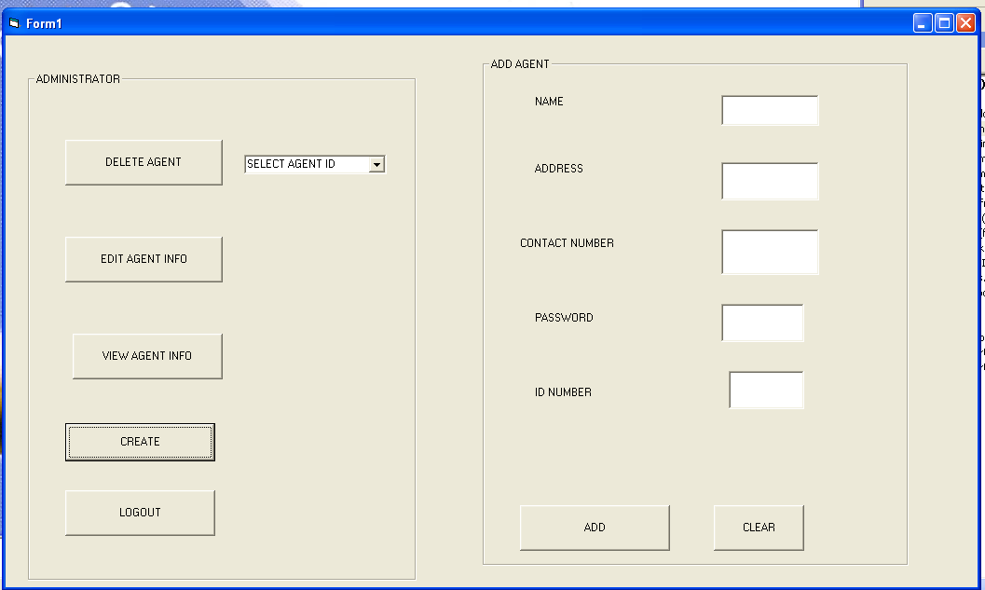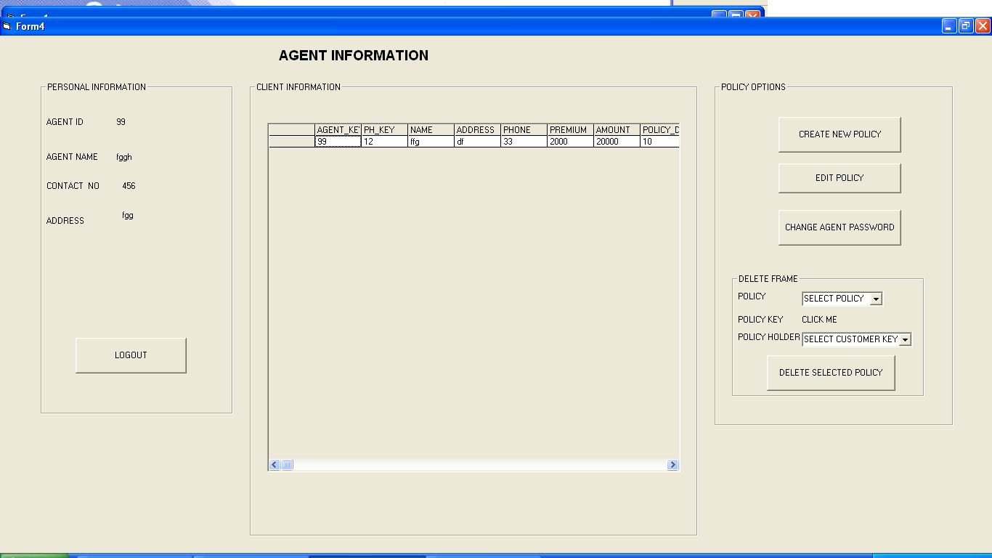

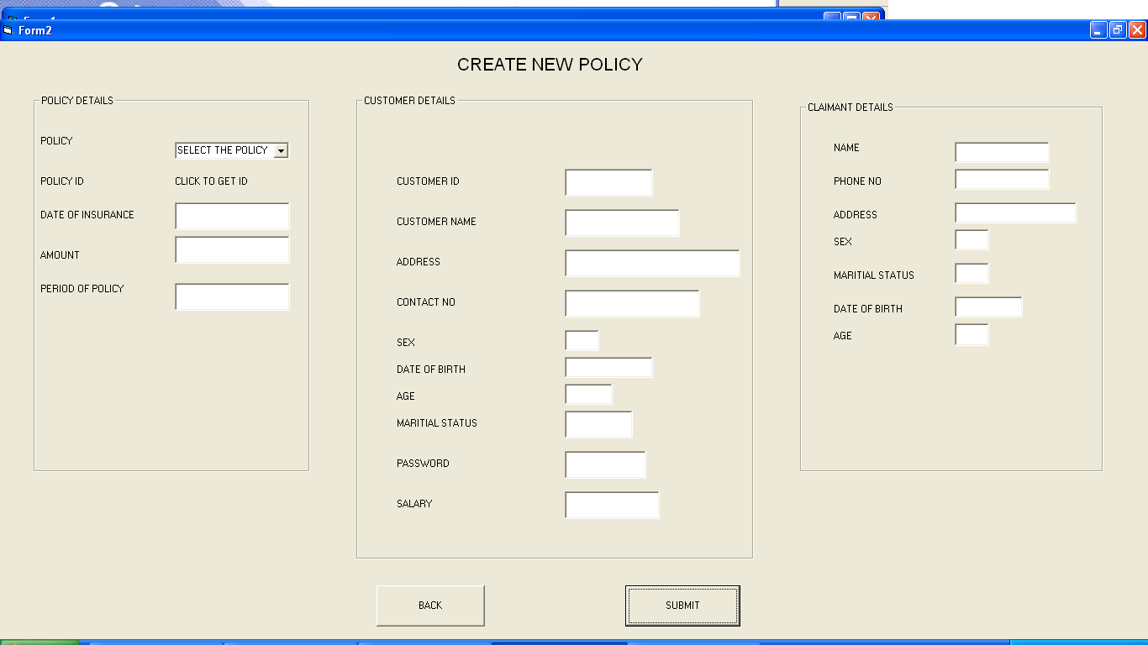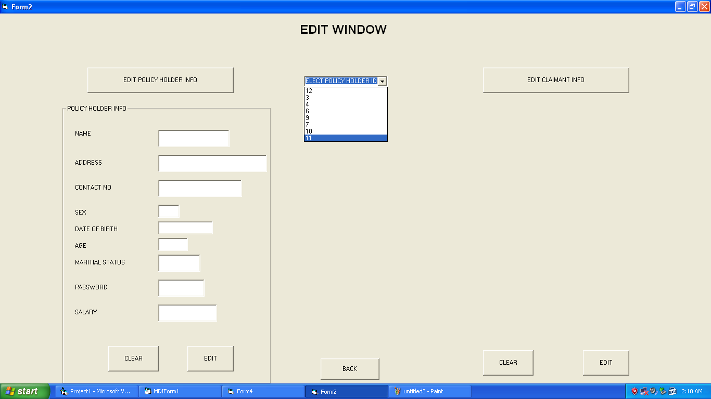

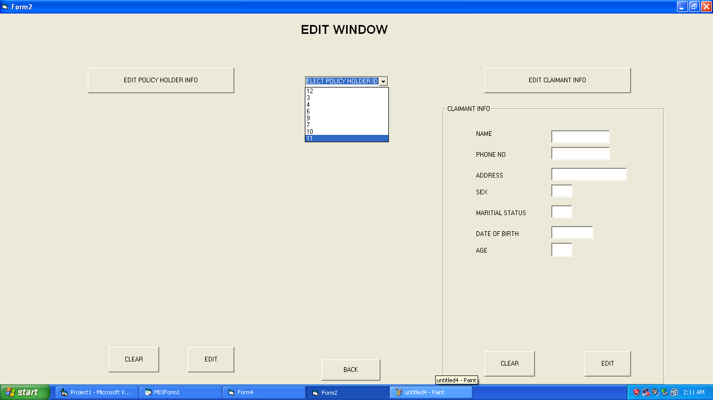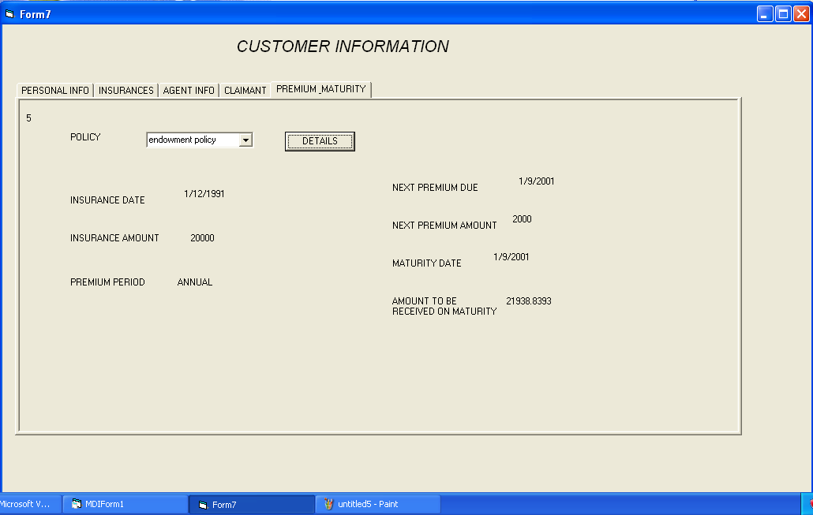

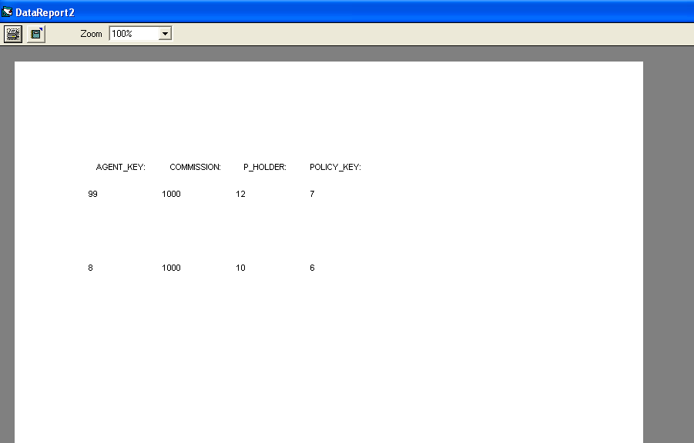

CONCLUSION

A computerized insurance management system has been developed and the system was tested with sample data.

The system results in regular timely preparations of required outputs. In comparison with manual system the benefits under a computer system are considerable in the saving of man power working hours and Effort.

Provision for addition , updation and deletion of customers is there in the system .It is observed that proper filing system has been adopted for future refernce . The entire project runs on windows environments.

The system can be used to make better management described at appropriate time. The user gets amount and timely information system.

SCOPE OF ENHANCEMENT

The system may be further updated or modified at will owing to its simple structure. We can further add a transaction entity which will look after the payments made by the customer towards their policy. Depending on future requirements more changes can be made owing to the organization’s need.

